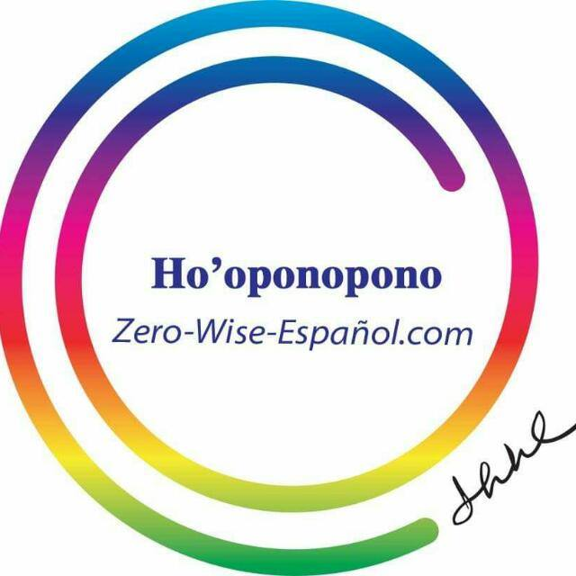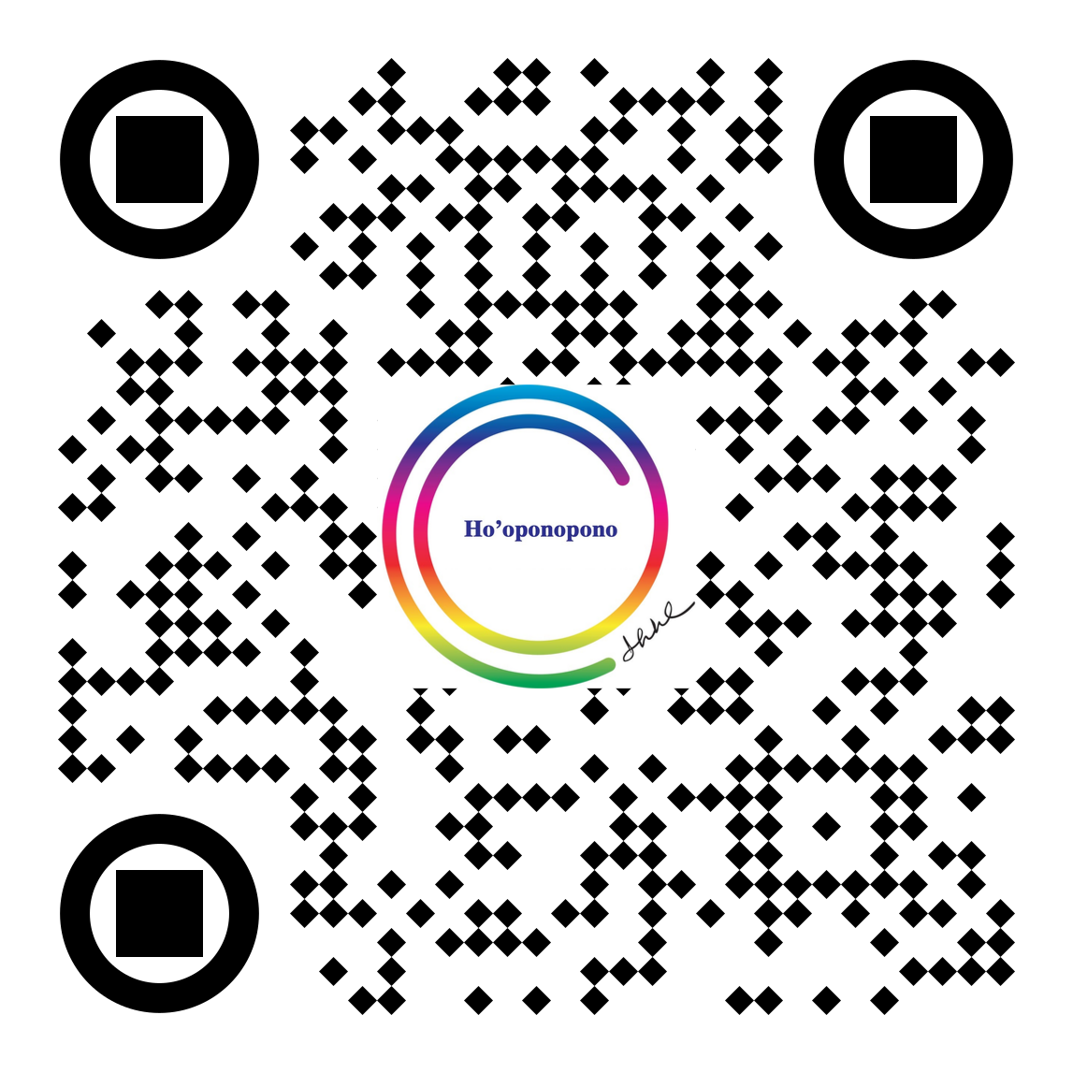Z

**SITH® BASIC I CLASS 2024**

Tijuana BC. Mexico

**IZI LLC Lecture Basic I**

ONLINE Tuesday, September 24, 2024

10:00am to 1:00 pm. PST

Language: English with Spanish Translation

FEE: $ 585 MXN

**SITH BASIC I CLASS**

Octuber 5 & 6, 2024

10:00 am to 5:00 pm. PST

Language: Spanish only.

**Online thru ZOOM**

**In Person:** Will be announced

**Instructors:**

#### Martha Ugarte,

#### Elena Maria Gonzalez Expósito

**Contact:**

Pele'i'ake M. Ugarte

Ho’oponopono Zero Wise

hooponoponozw@gmail.com

WhatsApp +1(818)398-2578

www.self-i-dentity-through-hooponopono.com

www.hooponopono-zero-wise.com

What is Ho'oponopono?

IZI LLC sponsors Self I-Dentity through Ho’oponopono® (SITH®) is an updated Hawaiian problem solving process to release memories that are experienced as problems. SITH® was developed by Morrnah Nalamaku Simeona, a Hawaiian Kahuna Lapa’au. She was recognized in Hawaii as a Living Treasure of Hawaii in 1983.

***When we are willing to take 100% responsibility and let go, what is right and perfect unfolds.***

The updated IZI LLC sponsors Self I-Dentity through Ho’oponopono®️ process provides “a step by step approach to achieving Peace, Balance and a new meaning of life through an understanding of one’s Self-I-dentity.”

**ONLINE & IN PERSON**

SPONSORS